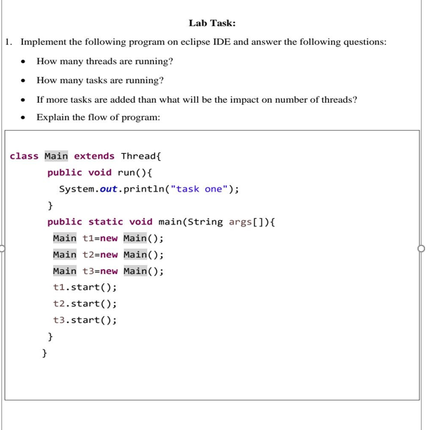

The provided code defines a `Main` class that extends `Thread`, allowing each instance to run as a separate thread. In the `main` method, three instances of `Main` (`t1`, `t2`, `t3`) are created, and `start()` is called on each one, beginning their execution as independent threads.

1. Threads Running: Three threads are running (`t1`, `t2`, `t3`), as each instance of `Main` is a separate thread when `start()` is called.

2. Tasks Running: Three tasks are running, as each thread executes the `run()` method, which prints "task one" to the console.

3. Impact of Adding More Tasks: Adding more tasks by creating additional instances (e.g., `t4`, `t5`) and calling `start()` on them will increase the number of threads. This could lead to higher memory and CPU usage, as each thread consumes system resources.

4. Flow: The program creates three threads that each execute the `run()` method and print "task one." Since threads run concurrently, the order in which "task one" is printed may vary with each program run due to the nature of multithreading.

